To: Dr. Oman
From: Traffic team
Date: 6/19/2020
Re: Hardware Review I
This memo is providing the hardware review I of the project. The purpose of the project is to develop a device that can clean the traffic sign boards on highways without interrupting the flow of traffic. The design has created that consist of a drone system with the pipe structure and shower system present in front along with the nozzles to throw the water on the sign board and clean the board with the brush. The final design has shown below in the figure
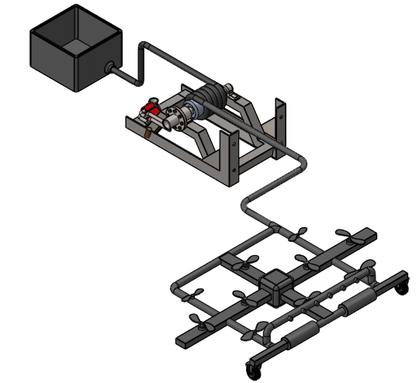
Figure 1: Final Design
The final design selected for the system consist of the following items:
- Propellers
- Drone Structure with pipes
- Arduino UNO R3
- Brushes
- Motors
- Water tank
- Reel and Hose
- Remote Controller
Propellers
Two side propellers are going to use for this project because it can generate more power to fly the drone in the air. The number of propellers we are going to use 10, with the strategy of 3 propellers at front, 4 in the middle and 3 propellers at the back. The reason to use this strategy is that the drone will fly along with the pipe structure that will have water flowing as well so using 10 propellers with this strategy will able to lift the drone. One propeller can produce the lifting capacity as
$$V_{a}=140 knots=72.022\frac{m}{s}$$
$$V_{e}=170 knots=87.4556\frac{m}{s}$$
$$F=Density*Area*\left(V_{e}^{2}-V_{e}V_{a}\right)$$
$$Density of Air=1.225\frac{kg}{m^{3}}$$
$$Area=0.0052 m^{2}$$
$$F=1.225*0.0052*\left({43.5}^{2}-43.2*40\right)$$
$$F=8.5979 N$$

Hence the total 10 propellers can produce the thrust force of
$$F=10*8.5979$$
$$F=85.979 N$$
While the weight of complete drone setup is less than 85 N hence the drone with 10 propellers can easily lift.
Drone Structure with Pipes
The pipes are connecting through the elbows and form a rectangular structure as showing in the figure.
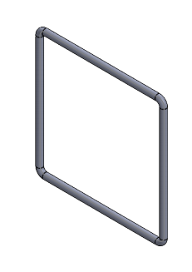
Figure 2: Drone Pipe Structure
These pipes are light weight and will make the structure strong. The pipe of ½ inch size will use with the inner diameter of 0.84 inches. The overall weight of the pipe structure is around
$$Pipe Structure Weight=5 lb$$
Hence this structure can easily lift by the 10 propellers. While the elbows have used at the bends to provide soft edges that will not hurt anyone and safe to use as well.
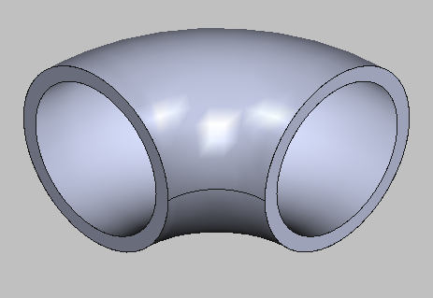
Figure 4: Elbows
Arduino UNO R3
The basic module of Arduino is Arduino UNO R3, which has all the basic functionality so this Arduino controller is using in this device. It will connect with the motors and the remote controller to control the system and it will also connect with the shower system to throw the water on the sign boards. The Arduino controller will take the power from the power source. The Arduino is showing below
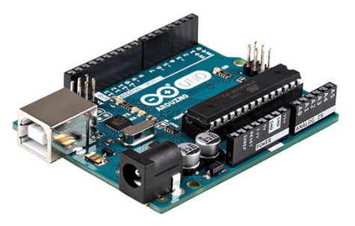
Figure 3: Arduino UNO R3
This controller will code in C language and compile that C language program on it because the Arduino can compile the C language along with Arduino language, so coding will do in C language to make the commands and controls easy to use.
Brushes
The brushes are going to use to clean the sign boards so the length of the brush teeth is around 2 to 5 inches long made up of fabric. As the fabric is soft enough to save the sing coating and have enough strength to absorb water from sign boards. The shape of brush is in roller form so that it can easily rotate and cleaning the sign boards becomes easy. The length of roller is around 8 inches hence two rollers are present in the design that will clean the sign boards and sign boards will easily clean.
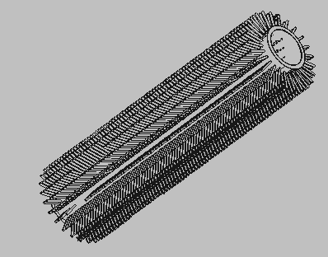
Figure 4: Brushes
The brushes will rotate with the help of motor in one direction to clean the sign boards.
Motors
The drone is using multiple motors around 12-14 motors will use in it and the motors that will use in the drone are DC motors. The DC motors that are going to use is 6 mm motor with 51000 rpm and because of high revolution speed these motors can easily lift up the drone.
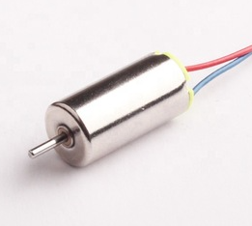
Figure 5: DC Motor of 6mm
The high revolution speed of 10 motors for the propellers can easily lift the drone, while the brush will use the low speed motor with high
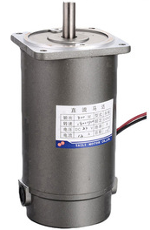
Figure 6: DC Motor
The above motor is 2000 rpm with the torque 1600mN.m and this motor can easily rotate the brush rollers for cleaning purpose.
Water Tank
The water tank will contain the water around 8 liters in a small bucket that will supply to the showers through the hose and reel. The water tank will make by light weight plastic so it can easily move from one point to another point.
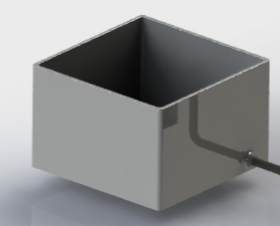
Figure 7: Water Tank
Reel and Hose
Reel and hose are connecting with the drone structure and place over the ground to provide the water and also provide the fail safety system. Fail safety system will provide the safety of device for the case if drone will not able to fly and stop running or malfunctioning then instantly hose and reel will rotate through the motor and provide safety to the drone and keep it safe from falling on the highway. In this way the drone will safe and coming to the ground, wheels will provide the lift to land it safely on the ground. The wheels are present on the front side while the hose is docking with the drone on the backside of the drone and it shown below in the following figure.
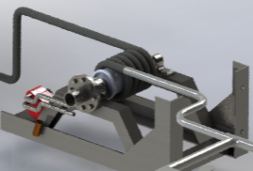
Figure 8: Reel and Hose for Fail Safe
Another function of hose is that the electric power wire will connect with the drone through it, and the electric supply will provide to the system by that wire and power will come from the sign boards connection itself.
Remote Controller
The remote controller will send the signals to the Arduino controller and controller will perform that ask according to what has sent to it. The remote controller buttons will send specific frequency to the Arduino channel and Arduino will recognize the frequency and pass on the task saved in it corresponding to that frequency. The remote controller will work on Radio frequency with the specified bandwidth and the program stored in Arduino will have the hard codded frequencies for each button hence each task can perform remotely like change the directions of drone, or move forward or throw the water or rotate the brush rollers, all the task can be done through the remote.
Conclusion
The hardware review has performed in this memo to present which components are using in the project and how the components are working in it. The use of 10 propellers with the scheme of 3-4-3 is good for the drone to lift it up. The motors of 6mm with 51000 rpm for the propellers can provide enough thrust and lifting capacity. The thrust that can produce minimum by the propellers is around 85 N, while the weight of whole device will be less than 30 lb. hence the device can easily lift up. The fail-safe system has installed in the design, reel and hose will work for the fail safety purpose and will also supply the water to the showers. In case of malfunctioning, the hose and reel will automatically roll down the drone and place it on the ground with the help of wheels to provide safe landing.

References
[1] M. Sid, “PVC and CPVC Dimentions” , available [online], http://www.midcoonline.com/web/Pages/Products/Pipe/Info/PVC_CPVC/
[2] P. Robotics, “Arduino UNO R3”, available [online], https://www.pololu.com/product/2191
[3] A. Baba, “6mm Micro DC motor for mini Drone 3.7v 51000rpm, drone motor”, available [online], https://www.alibaba.com/product-detail/6mm-micro-DC-motor-for-mini_60347921815.html
[4] T. Sandmen, “Roller Shutter Motor Small Electric DC Motor”, available [online], https://www.alibaba.com/product-detail/Roller-shutter-motor-price-small-electric_60768132284.html

